Unit Repossession – Brand New Units

- Purpose

When a new motorcycle unit arrives, the Product Pricing-In-Charge personnel will encode the product details in the Brand New Units menu item.

- Views
  - List View
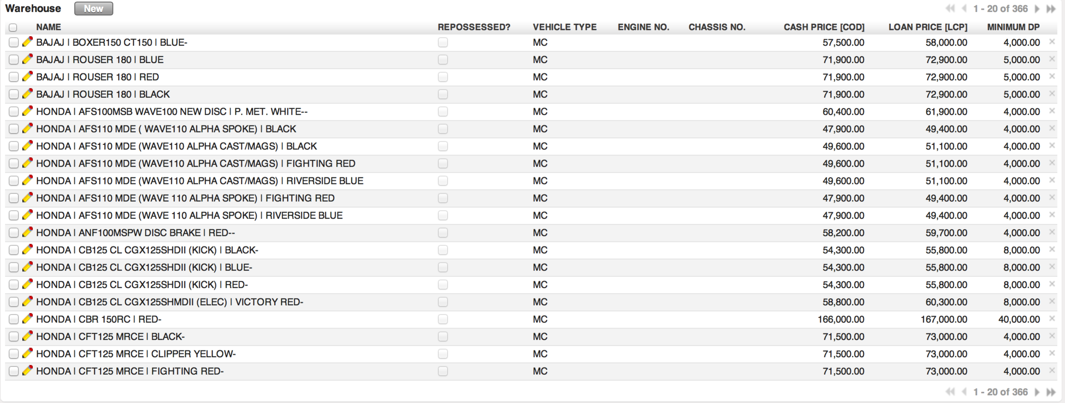
Figure 1. List view of Brand New Units

  - Form View
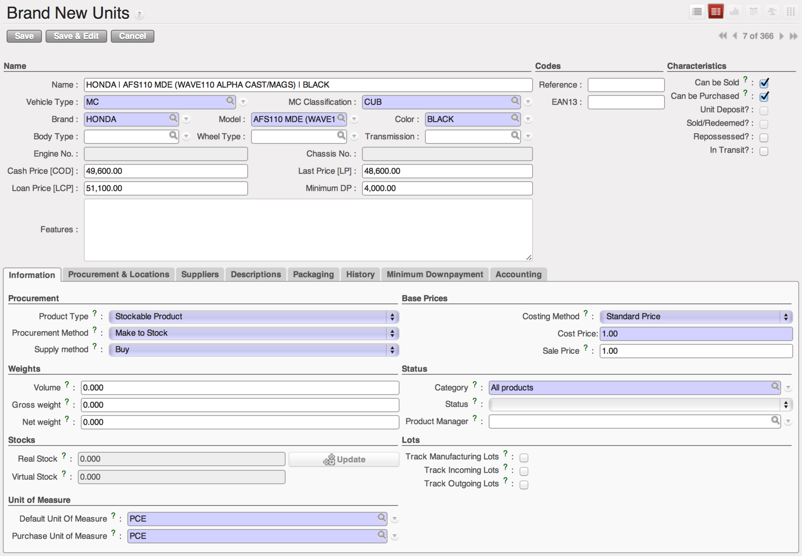
Figure 2. Form view of Brand New Units

- Menu and Access Rights
  - Menu – Warehouse > MC Units > Brand New Units
  - Access Rights
Role | Read | Write | Create | Delete
Product Pricing-In-Charge | Yes | Yes | Yes | No
CI/Collector | Yes | No | No | No
Receptionist | Yes | No | No | No
Branch Manager | Yes | No | No | No

- Required Fields
All required fields can be easily distinguished from the form view. These are the fields highlighted in Figure 2.

- Vehicle Type – either ‘MC’ or ‘CAB’
- MC Classification – specifies the breaking period and the basis of 1st due date
- Brand – brand name of MC unit
- Model – model name of MC unit
- Color – color of MC unit
- Product Type – set to ‘Consumable’
- The following the required fields should be left as is: Procurement Method, Supply Method, Costing Method, Cost Price, Sale Price, Category, Default Unit of Measure and Purchase Unit of Measure.

- Workflow
No workflow is defined for this submodule.

- User Action
No user action is defined for this submodule.

- Field Visibility
All fields are visible to all users with read access to the record.

- Reports and Print Outs
No print outs or reports define for this submodule.

